MasterThesis

**Optical investigations at the metal-insulator-transition**

When a metal turns bad, it loses its conducting properties but also the high reflectivity.  
Silver cutlery has to polished regularly, old mirrors fade with time. While the optical properties of metals are commonly described by the Drude model, bad metals exhibits pronounced deviations from this behavior.

In this project we want to study granular aluminum as a model system of a Mott insulator. These aluminum films consist of nanometer-sized grains and their electronic properties can be tuned over many orders of magnitude. How does this affect the optical properties? We want to perform infrared investigations of granular aluminum films in order to see how the Drude peak becomes displaced with increasing granularity.

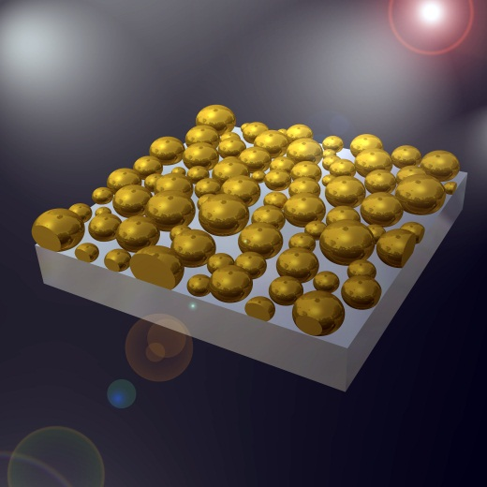 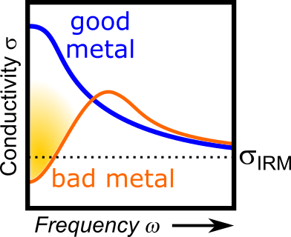

Contact: M. Dressel, M. Scheffler

Keywords: bad metal, granular aluminum, displaced Drude peak, infrared-optical spectroscopy